CA-16
2016 IE Strategy Memorandum
Updated on 5/2/16

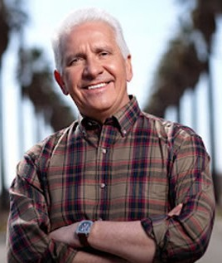


CONGRESSMAN JIM COSTA DAVID ROGERS
CoH: $1,253,526.36 CoH: $110,399.65
Date: 4/15/16 Date: 4/15/16
Occupation: Farmer Occupation: Small Businessman



JOHNNY TACHERRA
CoH: $36,988.71
Date: 4/15/16
Occupation: Dairy Farmer

SECTION I: Race Overview
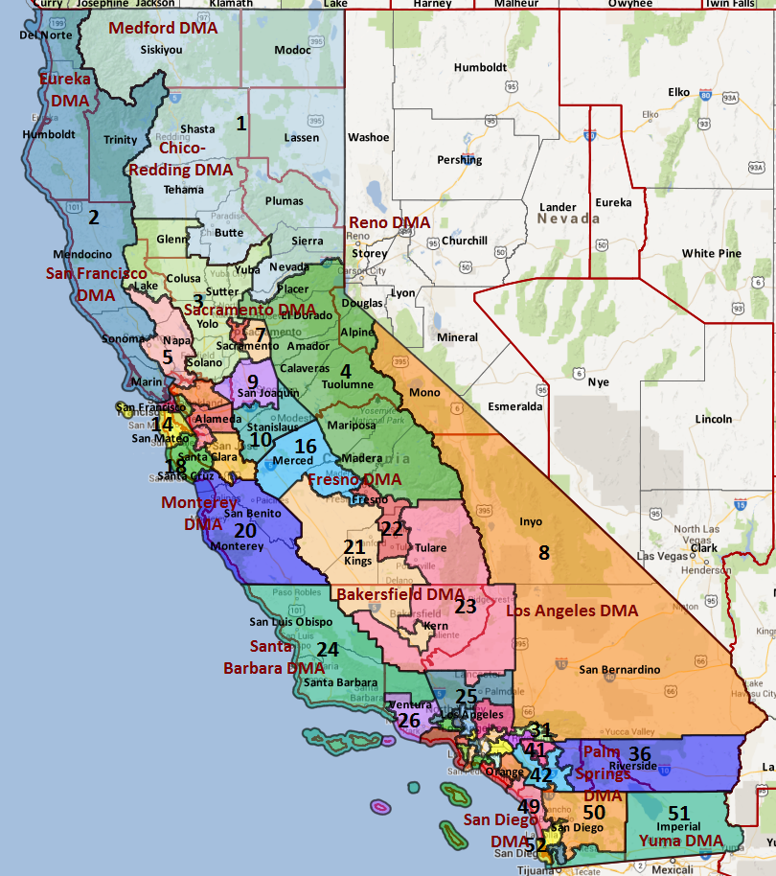

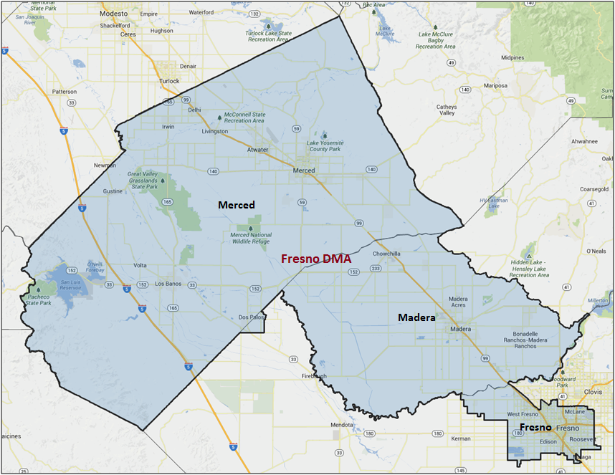

Media Market Costs

TV DMA | % of  CD | I.E.  35+ CPP | Cable CPP
FRESNO-VISALIA | 100% | $155 | $275
CA-16 TOTALS: | 100.0%
Radio Landscape

Merced
Universe Size | CPP
118,200 | $62

Digital Landscape
- CA-16
  - Persuasion universe size: 16,319
  - Audience extension (key demos): Hispanic, 18-30
  - Weekly budget for full coverage: $5,920.55
  - Reach
    - YouTube - 308,177
    - Pandora - 246,005

Presidential Statistics
Cycle | Candidate | Party | Vote
2012 | Obama | DEM | 59.8%
2012 | Romney | REP | 40.2%
2008 | Obama | DEM | 58.6%
2008 | McCain | REP | 41.4%

Congressional Statistics
Cycle | W/L | Candidate | Party | Vote
2014 | W | COSTA | DEM | 50.7%
2014 | L | TACHERRA | REP | 49.2%
2012 | W | COSTA | DEM | 57.4%
2012 | L | WHELAN | REP | 42.6%

NCEC Data
Dem Performance: 56.2%
BVAP: 7.8%
Hispanic: 43.4%
Asian: 9.2%
Total Minority: 60.4%

Critical Dates
Filing Date: March 25th 2016
Primary Date: June 7th 2016

Summary of 2014 Cycle Spending by Outside Groups to Date

None

Summary of 2012 Spending by Outside Groups

None
Pre-Election Day Voting

Type of  “Early Voting” | Start Date  End Date | Percent of  Vote Cast Using this Method | Brief Description  (where/how  do people vote) | Timeframe (when does the majority of voting happen)
Early Vote | Oct 8 –Nov 8 |  | Voters can bring their early ballots to the board of elections office or be issued a ballot at the office at the time of their visit
Absentee Ballot/In person Absentee | Oct 10 – Nov 11 |  | Voters must apply for an absentee/VBM ballot via mail, online, or in person | Absentee applications must be received by BOE at least 7 days before election day
Vote By Mail | Oct 1 – Nov 11 |  | Voters must request to VBM each election unless on PEVL - VBM must be received by BOE by Nov 11 and be postmarked before election day | Ballots return steadily.

Tentative Campaign Timeline

IMPORTANT DATES

VBM: Oct. 10 – Nov. 11

